2018 U.S MASTERS SWIMMING
HIGH PERFORMANCE CAMP
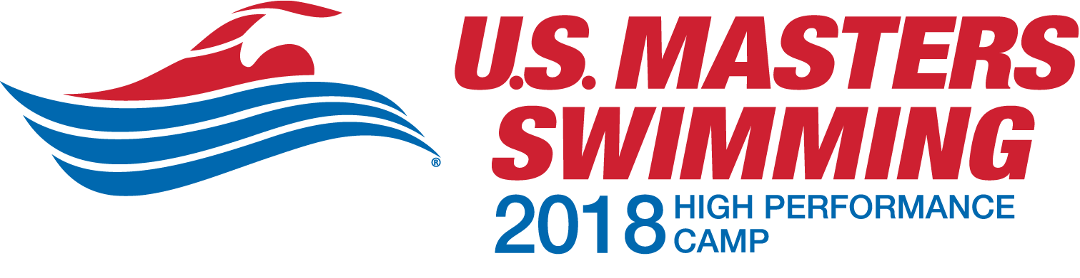

Aug. 25 – Aug. 30, 2018

HOSTED BY

The Triangle Sports Commission,

a U.S. Masters Swimming Community Partner

IN PARTNERSHIP WITH
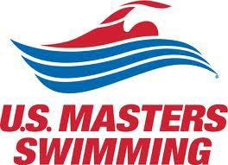

GENERAL INFORMATION

Dates: Sat., Aug. 25- Thurs., Aug. 30, 2018
Location: Greensboro Aquatic Center Greensboro, NC
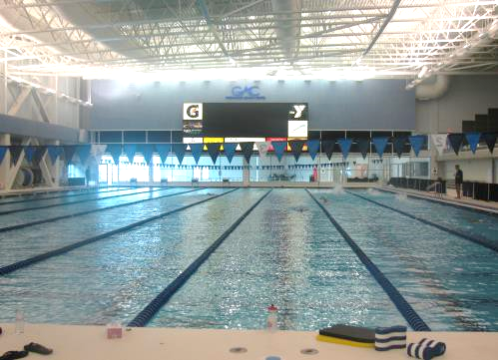

Site of the 2012 USMS Spring Nationals and the 2016 USA Masters Games

Housing: Campers will be housed at the Holiday Inn Greensboro Coliseum, which is a 5-minute shuttle ride from the Greensboro Aquatic Center

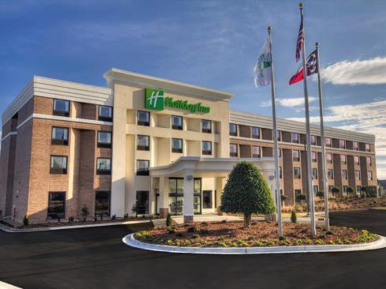

Sessions: Campers will be exposed to various training and competition techniques by a highly experienced staff. High Performance Camp is designed specifically for Masters Swimmers who want to improve their swimming. Campers will also participate in both pool and dryland training sessions. Campers will hear from a variety of speakers such as coaches, sports psychologists, and nutritionists, all of whom are focused on the specific demands of masters swimming.

ABOUT THE CAMP

This outstanding camp is offered to Masters swimmers through the combined efforts of United States Masters Swimming, the Triangle Sports Commission, and the Greensboro Aquatic Center. The camp is hosted by the Triangle Sports Commission, a U.S. Masters Swimming Community Partner, and is supported locally by the Greensboro Convention and Visitors Bureau.

The camp is limited to a small number of dedicated Masters swimmers who are committed to advancing their skills and performance. You’ll be taught and analyzed by outstanding U.S. Masters Swimming coaches and professionals in the fields of sports psychology, physiology, biomechanics, nutrition, technique, resistance and flexibility training.

WHAT YOU’LL DO

The camp emphasis is on testing and education. Pool time is dedicated to technique improvement rather than conditioning. You’ll be tested for your Heart Rate/ Lactate threshold and you’ll be filmed above and below the water. Stroke analysis, flexibility and range of motion (ROM) assessment and instruction, sports psychology consultations, motivational and classroom presentations on topics such as biomechanics, physiology, sports psychology and training are all part of the program.

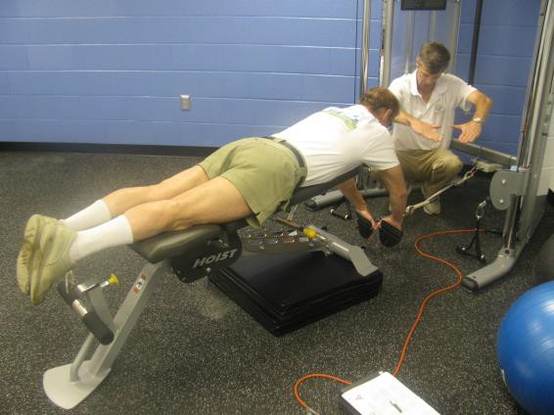

WHAT YOU’LL LEARN
You will learn the most up-to-date Masters training and competitive theories and techniques and be able to correlate them to your personal swimming program and goals. Significant time will be devoted to providing individual results of, and feedback on, all testing. Computerized biomechanic analysis of your stroke, body physiology, videotape review, flexibility and range of motion assessment results and recommendations, lactate and nutrition assessment, and recommendations will be included. You will receive expert instruction and a critique of starts, turns, and drills. You’ll take home a flash drive with handouts, videos, and presentations along with personalized training program recommendations.

This camp will be intense, but there will be plenty of opportunity for interaction and socialization with the other Masters athletes.

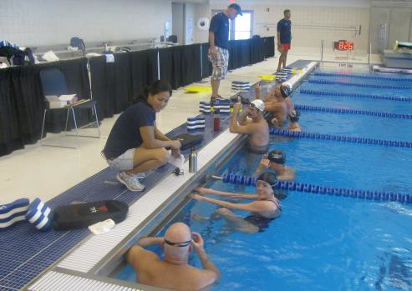

ADDITIONAL INFORMATION…

Any Masters swimmer is eligible to attend this camp. The fee for the camp is $2200, and includes room (2 campers/room), board, all ground transportation including to and from the airport (airfare is not included), instructional materials, camp shirt, and other gifts.

Campers will arrive on Saturday by mid-day and depart on Thursday morning. The primary criteria for selection include: a balance of men and women, previous swimming achievements, swimming background, and workout/training schedule.

APPLICATION FOR THE USMS HIGH PERFORMANCE CAMP
Early Admission: Similar to college applications, you can apply for the upcoming HPC in the following year, during the fall of the preceding year. You will be informed of your acceptance in early December and to confirm your slot, you will need to pay half the camp fee prior to the end of the calendar year. There is an incentive of a $200 discount off the standard HPC fee of $2,200 for Early Admissions. In other words, if a participant is accepted for Early Admission, the total fee for the camp will be $2,000, half of which ($1,000) is due prior to the end of the calendar year preceding the camp. (If an applicant is not accepted for Early Admission, their application will still be considered for Rolling Admission [see below] and the HPC will make suggestions on enhancements that will improve chances for admission during the Rolling Admissions process.)

Once you are selected, the first payment is due within 30 days of notification of acceptance and the second payments is due by July 1 (the fee can also be paid in a single payment). For further information, contact Hill Carrow at hcarrow@trianglesportscommission.com

Rolling Admission: Starting on January 1 of the year of the HPC, through the end of the application period in May of that year, the HPC will review applications as they come in and provide an acceptance (or not) notification to the applicant within a week. To confirm their slot at the camp, the accepted applicant will then need to remit half the camp fee ($1,100) within 30 days of the notice of their acceptance. (If not accepted to begin with, similar to the Early Admission process, the applicant's application will still be considered throughout the remainder of the application period and the HPC will make suggestions on enhancements that will improve chances for admission.)

Once you are selected, the first payment is due within 30 days of notification of acceptance and the second payments is due by July 1 (the fee can also be paid in a single payment). For further information, contact Hill Carrow at hcarrow@trianglesportscommission.com

These new procedures are designed to give applicants more direction and certainty much earlier on in the process than previous, and to secure commitments for the camp sooner, rather than later, which aids in camp planning and delivery of a superior camp experience.

Please answer the following questions and return by mail or fax to Hill Carrow at the address below:

Hill Carrow
Triangle Sports Commission
401 Harrison Oaks Boulevard, Suite 215
Cary, NC 27513
919-678-1655 fax
hcarrow@trianglesportscommission.com

Campers will arrive on Saturday by mid-day and depart on Thursday morning. Applications are accepted throughout the year and early applications are encouraged. Priority is given by date received. Final deadline for applications (i.e. postmarked or faxed) is FRIDAY, May 18th. You will be notified of your acceptance within a week.

The primary criteria for selection include: a balance of men and women, previous swimming achievements, swimming background, and workout/training schedule. Due to the limited number of participants (maximum of 20) and the strong interest in participation, your application will be rolled over for the next camp if you are not selected unless you indicate otherwise.

Type your answers to the following questions and return by mail, fax, or email. (You may use your own format if desired. Keep a copy for your records.)

- NAME _________________________________________________________

- GENDER _________________________________________________________
- ADDRESS _________________________________________________________
- E-MAIL _________________________________________________________
- PHONE (Cell)_______________________ (Home)_____________________
(Work) ______________________
- AGE _________________________________________________________
- DATE OF BIRTH ____________________________________________ (MM/DD/YYYY)
- OCCUPATION ___________________________________________________
- CURRENT USMS # ___________________________________________________
- TEAM _________________________________________________________
- Reasons for wanting to attend the camp:
- List your major swimming achievements (USMS Top Ten placings within the past 2 years, regional placings, contributions to Masters swimming – national, regional, local):
- List recent training background (pool, weight training & flexibility, cross training):
- What is your best event?
- How will you share what you learn at camp?
- Date of application: _________________________________________________________
- Indicate whether you wish your application to be considered for future camps?
YES NO

